# IMG_256HOSTING A WEBSITE ON CLOUD WITH ROUTE

Table to contents

1.)**Introduction**

1.1) Cloud

1.2) Types of cloud

1.3) Cloud models

2.)Domian registration

3.)Ec2

4)Route 53

5)Load balancer

**INTRODUCTION**

Cloud

**cloud** computing means storing and accessing data and programs over the Internet instead of your computer's hard drive. The **cloud** is just a metaphor for the Internet. ... Storing data on a home or office network does not count as utilizing the **cloud**

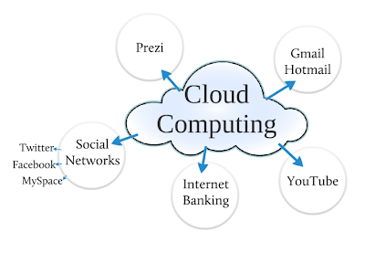

**TYPES OF CLOUD**

****Private cloud****, also called internal cloud or corporate cloud, means having a cloud environment dedicated for just one company. Private cloud provides higher security and privacy, which are needed in certain industries for regulatory reasons when organization needs to store and process confidential data or carry out sensitive tasks. It also gives more control for the company, which on the other hand requires more resources in hardware management.

****Public clouds****, in contrast to private clouds, provide services to multiple clients using the same shared, external infrastructure. The best-known public cloud service providers are Microsoft Azure and Amazon Web Services (AWS). With public clouds, companies can save the expensive costs of having to purchase, manage and maintain on-premises hardware and application infrastructure – the cloud service provider is responsible for all management and maintenance of the system. Public clouds can also be deployed faster than on-premises infrastructures and with an almost infinitely scalable platform.

**Hybrid Cloud** refers to the cloud infrastructure environment that is a mix of publicand private cloud solutions. ... As a result, access to additional computing capacity does not require the high CapEx of a private cloud environment but is delivered as a short-term IT service via apublic cloud solution.

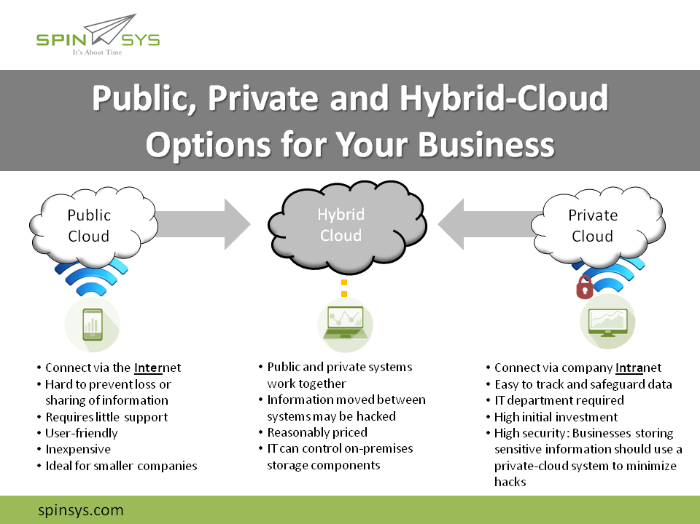`

Cloud models

### Software as a Service (SaaS).

The capability provided to the consumer is to use the provider’s applications running on a cloud infrastructure2. The applications are accessible from various client devices through either a thin client interface, such as a web browser (e.g., web-based email), or a program interface. The consumer does not manage or control the underlying cloud infrastructure including network, servers, operating systems, storage, or even individual application capabilities, with the possible exception of limited user-specific application configuration settings.

### Platform as a Service (PaaS).

The capability provided to the consumer is to deploy onto the cloud infrastructure consumer-created or acquired applications created using programming languages, libraries, services, and tools supported by the provider.3 The consumer does not manage or control the underlying cloud infrastructure including network, servers, operating systems, or storage, but has control over the deployed applications and possibly configuration settings for the application-hosting environment.

### Infrastructure as a Service (IaaS).

The capability provided to the consumer is to provision processing, storage, networks, and other fundamental computing resources where the consumer is able to deploy and run arbitrary software, which can include operating systems and applications. The consumer does not manage or control the underlying [cloud infrastructure](https://www.paranet.com/solutions/cloud/" \o "cloud infrastructure" \t "https://www.paranet.com/blog/bid/128267/_self) but has control over operating systems, storage, and deployed applications; and possibly limited control of select networking components (e.g., host firewalls).

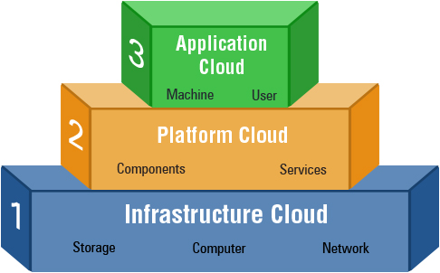

IN OUR PROJECT WE HAVE USED IAAS I.E AWS(AMAZON WEB SERVICES)

AMAZON WEB SERVICES

Amazon Web Services (AWS) is a bundled remote computing service that provides cloud computing infrastructure over the Internet with storage, bandwidth and customized support for application programming interfaces (API).

Launched in 2006, AWS is provided by cloud solution concept pioneer Amazon Inc. Amazon's internal IT resource management built AWS, which expanded and grew into an innovative and cost-effective cloud solution provider.

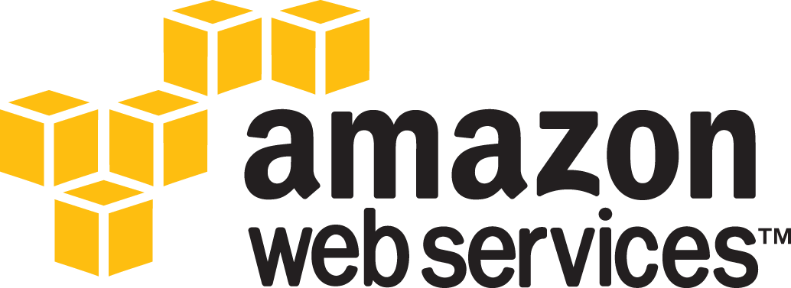

AWS services include:

* Amazon Elastic Computer Cloud (EC2)
* Amazon Simple Storage Service (Amazon S3)
* Amazon CloudFront
* Amazon Relational Database Service (Amazon RDS)
* Amazon SimpleDB
* Amazon Simple Notification Service (Amazon SNS)
* Amazon Simple Queue Service (Amazon SQS)
* Amazon Virtual Private Cloud (Amazon VPC)

WHY AWS?

ADVANTAGES OF USING AWS